Intro and menu are in English

There is also the need to include BVGH logo in the first slide

Pre-test
Questions do not correspond to the slides questions for pretest. The correct answers are the same as post-test.

The 2 slides on the ppt with the course overview were not in the platform -> to be added in welcome

Section 1: objectives (the screen I see in the RCB platform does not match with what Dr Marc sent)

there is a second slide from the ppt that does not appear in the platform -> good

Prostate icyo aricyo
Please remove the numbering as it is describing the prostate and not locations

After we click in all the numbers there is a message in English “all parts found” it should not be in English. If you keep numbers to see opening of all the boxes you just have to know that the text is not describing the anatomy but in the boxes, all the information is regarding prostate itself. Please refer to Dr. Marc slide. There are only 3 pieces of information and not 4

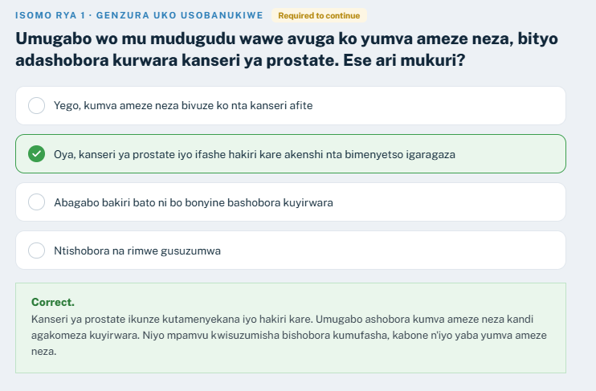
You see that after choosing the correct option you still see “required to continue” and “correct”. Please change the words to KW.

When it comes to the text for the learning there is also info in English (as in the print here)
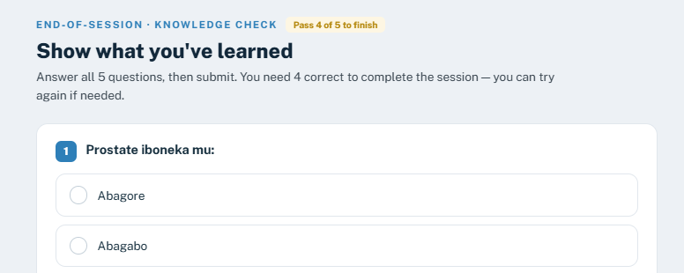

NOTE: the test is ok and also the options. At the end you see the same message in English “you scored 5/5 – passed”
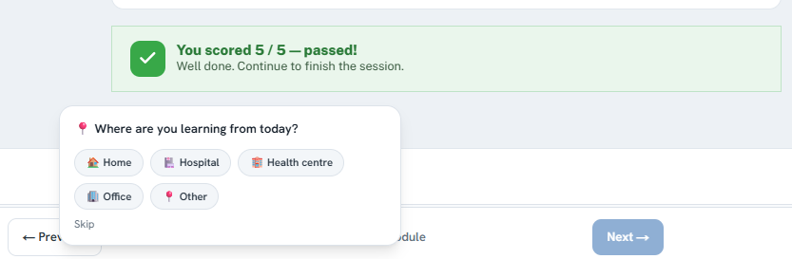

Session 1 reflection
It does not allow to write due to the same HCP error

After the reflection there is a mix of KW and English content
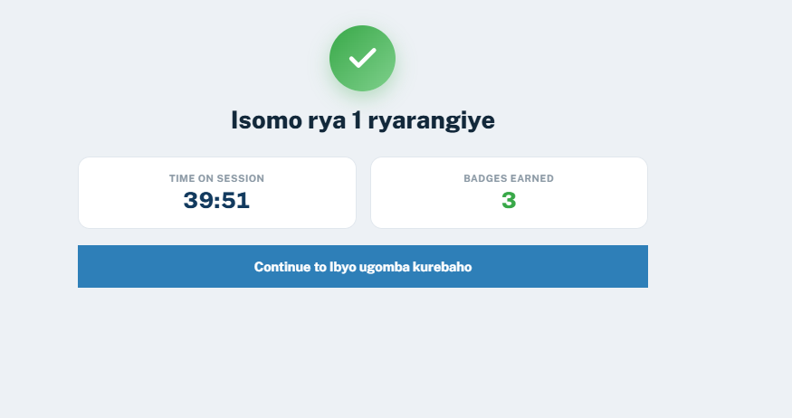

Section 2
When we have the video we also have content in English as “click to play” and “read the transcript”

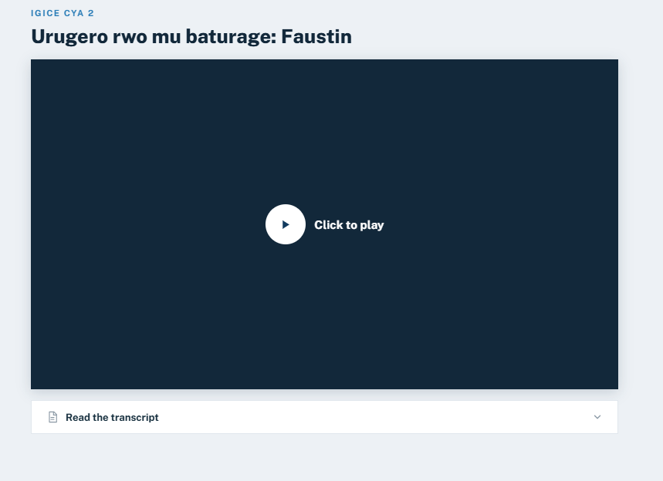

Same comment as before in the checking knowledge as there is still content in English “required to complete”
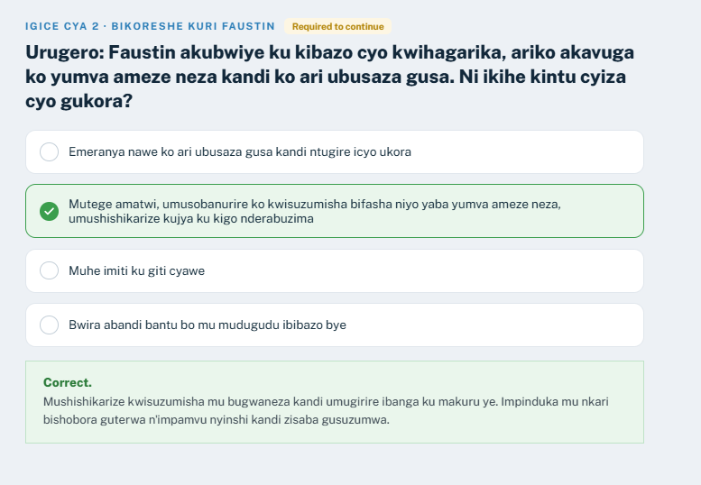

At the end the same comment as “5/5 -passed” should not be in english

Session 2 reflection
It does not allow to write due to the same HCP error

Section 3
Same comments as in previous ones “required to continue” and “correct”
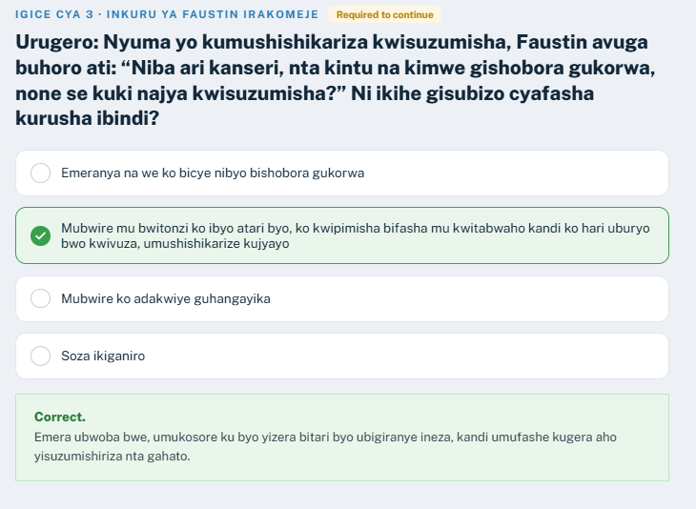

Session 3 reflection
It does not allow to write due to the same HCP error

Section 4
In this slide is not exactly the same as it is in the ppt provided.
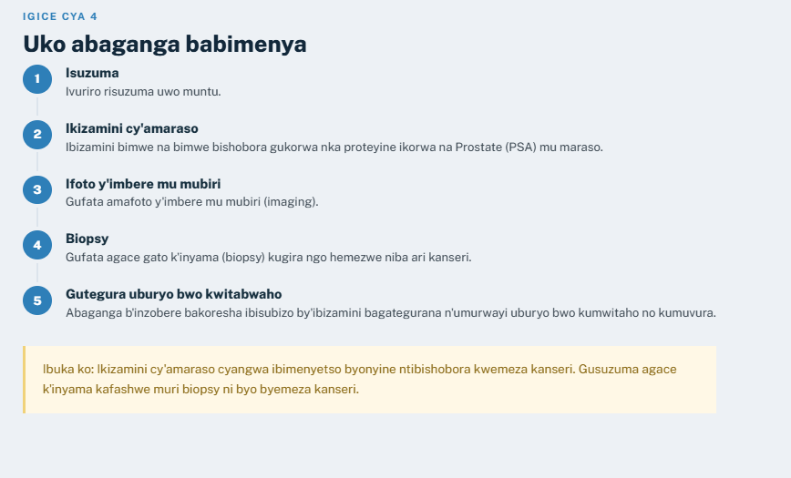

Session 4 reflection
It does not allow to write due to the same HCP error

Ingaruka zikunze guterwa n'ubuvuzi bwa kanseri ya prostate (slide 57)
Headers are missing. I updated it to be a table.

Its missing this part from the ppt

As it looks like this now (if space allows it would have a better reading if as it is in the ppt with the boxex having colours and text with bullets)

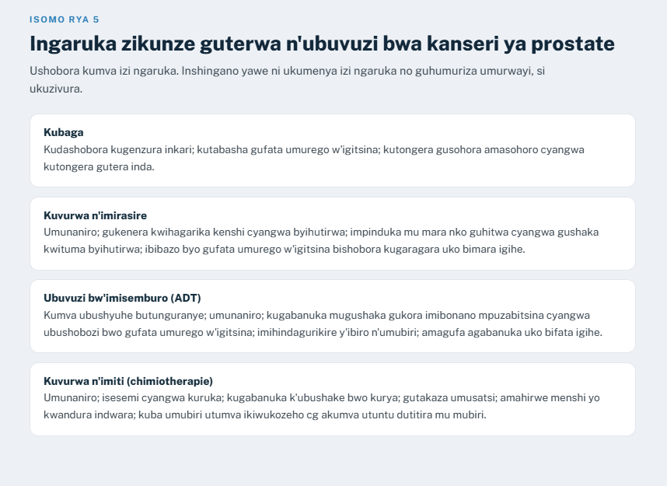

Ingaruka zo kuvura cyangwa ikibazo cy'uburwayi gishobora kubaho? (slide 58)
Color code missing. I updated it to be a table.

Ibimenyetso mpuruza bisaba kugira icyo ukora ako kanya (slide 59)
Internal subtitle in the square missing. Additionally text must be bulleted and not running text.

In the “show me what you have learnt section” question 1 is not with the changes from Dr. Marc ->

Session 5 reflection
It does not allow to write due to the same HCP error

